**Lab Exercise 3 | Week 4**

Implement ***Depth First Search (DFS) Algorithm*** *using adjacency list*.

1. Input: Graph as shown in the figure using adjacency list
2. Print the traversal of the search from given vertex ***u***.

* 4 3 2 7 8 6 5 1 (Refer Figure 1), when ***u*** is 1.

1. Print the tree edges and back edges. (Refer Figure 1)

* Tree edges: 1-2, 1-3, 3-4,1-5,5-6,6-7,6-8
* Back edges: 4-2

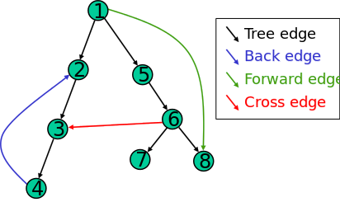

**Figure 1**: Example graph to be considered for implementation